# Design principles & Patterns:

Exercise 1: Implementing the Singleton Pattern

## Scenario:

You need to ensure that a logging utility class in your application has only one instance throughout the application lifecycle to ensure consistent logging.

## Code:

class Logger {

private static Logger instance;

private Logger() {

System.out.println("Logger instance created.");

}

public static Logger getInstance() { if (instance == null) {

instance = new Logger();

}

return instance;

}

public void log(String message) { System.out.println("Log: " + message);

}

}

public class Main {

public static void main(String[] args) { Logger logger1 = Logger.getInstance(); logger1.log("First message");

Logger logger2 = Logger.getInstance(); logger2.log("Second message");

System.out.println("Are both loggers the same instance? " + (logger1 == logger2));

}

}

## Output:

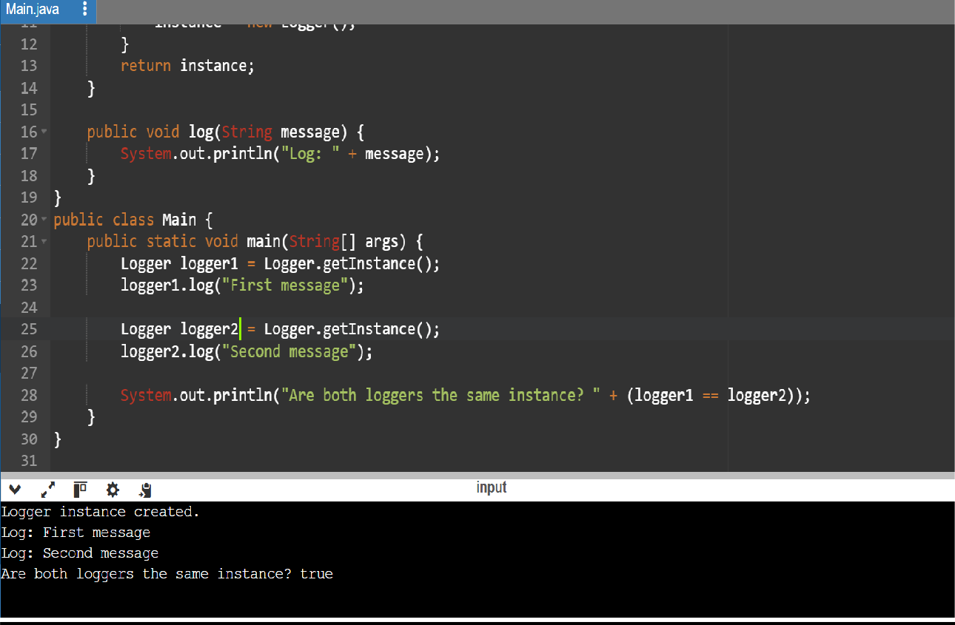

Exercise 2: Implementing the Factory Method Pattern

## Scenario:

You are developing a document management system that needs to create different types of documents (e.g., Word, PDF, Excel). Use the Factory Method Pattern to achieve this.

## Code:

interface Document { void open();

}

class WordDocument implements Document {

@Override

public void open() {

System.out.println("Opening Word document.");

}

}

class PdfDocument implements Document { @Override

public void open() {

System.out.println("Opening PDF document.");

}

}

class ExcelDocument implements Document { @Override

public void open() {

System.out.println("Opening Excel document.");

}

}

abstract class DocumentFactory {

public abstract Document createDocument();

}

class WordDocumentFactory extends DocumentFactory { @Override

public Document createDocument() { return new WordDocument();

}

}

class PdfDocumentFactory extends DocumentFactory { @Override

public Document createDocument() { return new PdfDocument();

}

}

class ExcelDocumentFactory extends DocumentFactory { @Override

public Document createDocument() { return new ExcelDocument();

}

}

public class Main {

public static void main(String[] args) {

DocumentFactory wordFactory = new WordDocumentFactory(); Document wordDoc = wordFactory.createDocument(); wordDoc.open();

DocumentFactory pdfFactory = new PdfDocumentFactory(); Document pdfDoc = pdfFactory.createDocument();

pdfDoc.open();

DocumentFactory excelFactory = new ExcelDocumentFactory(); Document excelDoc = excelFactory.createDocument(); excelDoc.open();

}

}

**Output:**

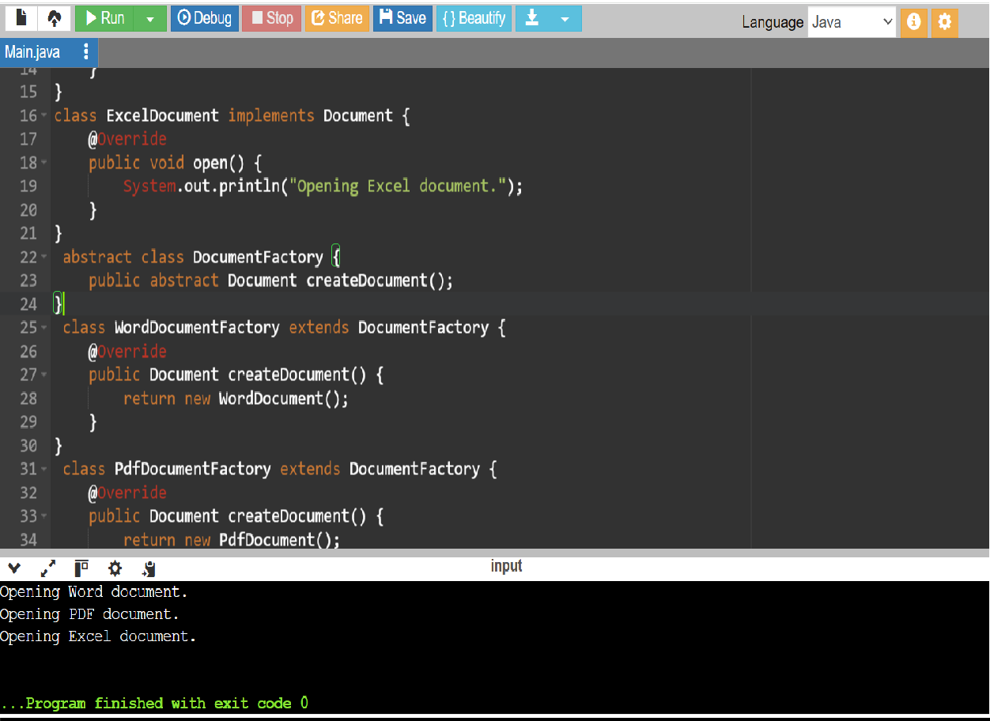

# Data structures and Algorithms

Exercise 2: E-commerce Platform Search Function

## Scenario:

You are working on the search functionality of an e-commerce platform. The search needs to be optimized for fast performance.

## Code:

import java.util.Arrays; import java.util.Comparator; class Product {

private int productId; private String productName; private String category;

public Product(int productId, String productName, String category) { this.productId = productId;

this.productName = productName; this.category = category;

}

public int getProductId() { return productId;

}

public String getProductName() { return productName;

}

public String getCategory() { return category;

}

@Override

public String toString() {

return "[" + productId + "] " + productName + " - " + category;

}

}

class SearchEngine {

public static Product linearSearch(Product[] products, String name) { for (Product p : products) {

if (p.getProductName().equalsIgnoreCase(name)) { return p;

}

}

return null;

}

public static Product binarySearch(Product[] products, String name) { Arrays.sort(products, Comparator.comparing(Product::getProductName,

String.CASE_INSENSITIVE_ORDER));

int low = 0;

int high = products.length - 1;

while (low <= high) {

int mid = (low + high) / 2;

int cmp = products[mid].getProductName().compareToIgnoreCase(name);

if (cmp == 0) {

return products[mid];

} else if (cmp < 0) { low = mid + 1;

} else {

high = mid - 1;

}

}

return null;

}

}

public class Main {

public static void main(String[] args) { Product[] catalog = {

new Product(101, "Laptop", "Electronics"),

new Product(102, "Shampoo", "Personal Care"), new Product(103, "Book", "Stationery"),

new Product(104, "T-Shirt", "Clothing"),

new Product(105, "Headphones", "Electronics")

};

Product foundLinear = SearchEngine.linearSearch(catalog, "T-Shirt"); System.out.println("Linear Search Found: " + (foundLinear != null ? foundLinear

: "Product not found")); Product foundBinary = SearchEngine.binarySearch(catalog, "T-Shirt");

System.out.println("Binary Search Found: " + (foundBinary != null ? foundBinary : "Product not found"));

}

}

**Output:**

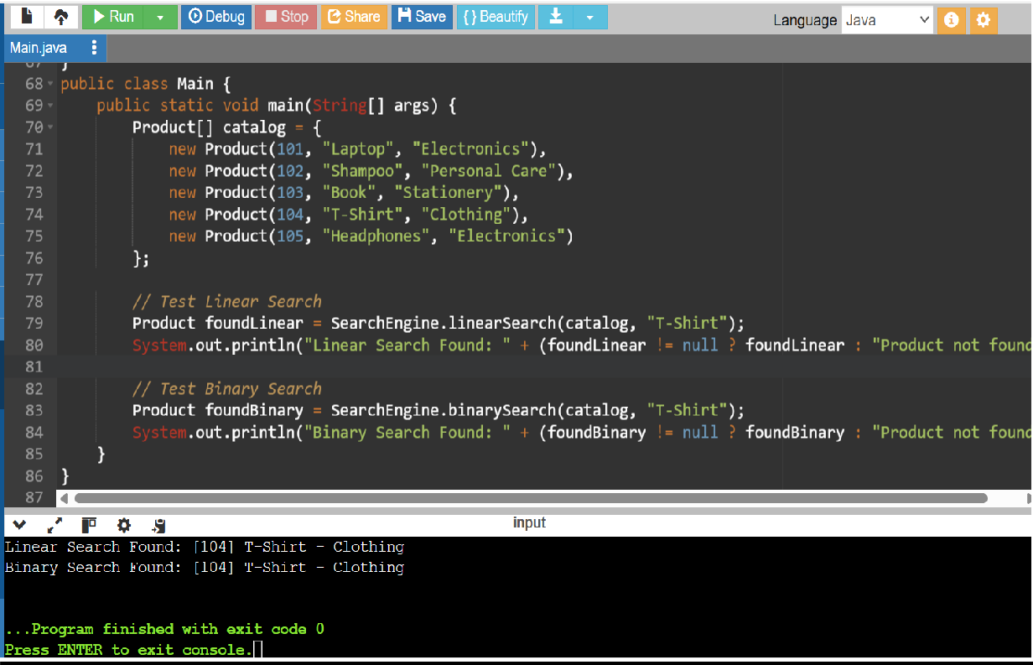

Exercise 7: Financial Forecasting

## Scenario:

You are developing a financial forecasting tool that predicts future values based on past data.

## Code:

public class Main {

public static double predictFutureValue(double amount, double rate, int years) { if (years == 0) {

return amount;

}

// Recursive step

return predictFutureValue(amount, rate, years - 1) * (1 + rate);

}

public static double predictIteratively(double amount, double rate, int years) { for (int i = 0; i < years; i++) {

amount *= (1 + rate);

}

return amount;

}

public static void main(String[] args) { double initialInvestment = 10000.0 double annualGrowthRate = 0.07; int forecastYears = 5;

double futureValueRecursive = predictFutureValue(initialInvestment, annualGrowthRate, forecastYears);

System.out.printf("Recursive: Predicted value after %d years: ₹%.2f\n", forecastYears, futureValueRecursive);

double futureValueIterative = predictIteratively(initialInvestment, annualGrowthRate, forecastYears);

System.out.printf("Iterative: Predicted value after %d years: ₹%.2f\n", forecastYears, futureValueIterative);

}

}

**Output:**

